|  |  |
| --- | --- |
| REGISTER NUMBER | 412720106013 |
| STUDENT NAME | SATHISH N |
| COURSE NAME | BLOCK CHAIN |
| ZONE | 4 |
| COLLEGE NAME | TAGORE ENGINERRING COLLEGE |

**ASSIGNMENT-1**

**STEP1**: Go to the chrome and open remix platform

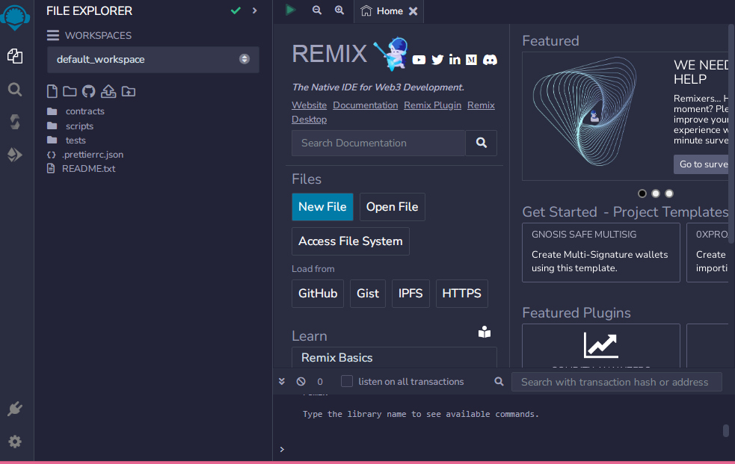

STEP2: Create a new file

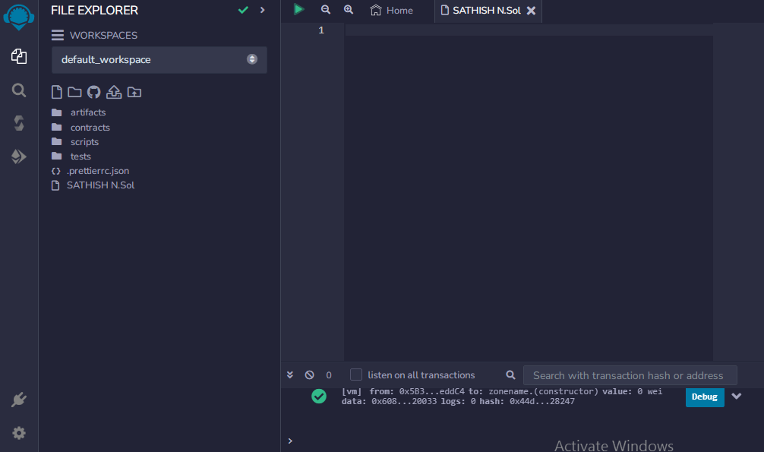

STEP3: In that newly created file, create a program to return your string, "Zone name"

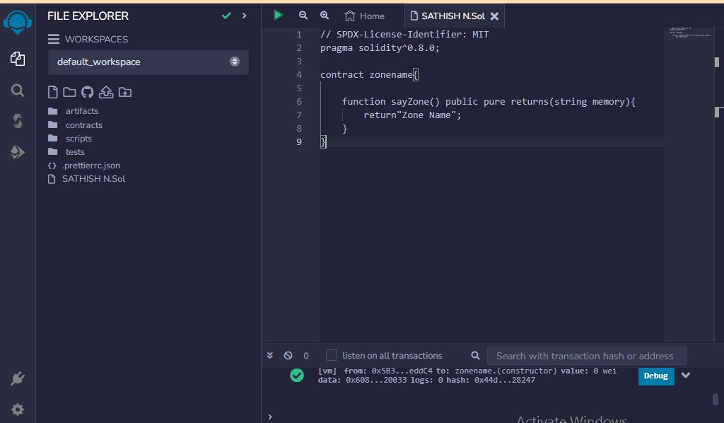

STEP4: Compilation

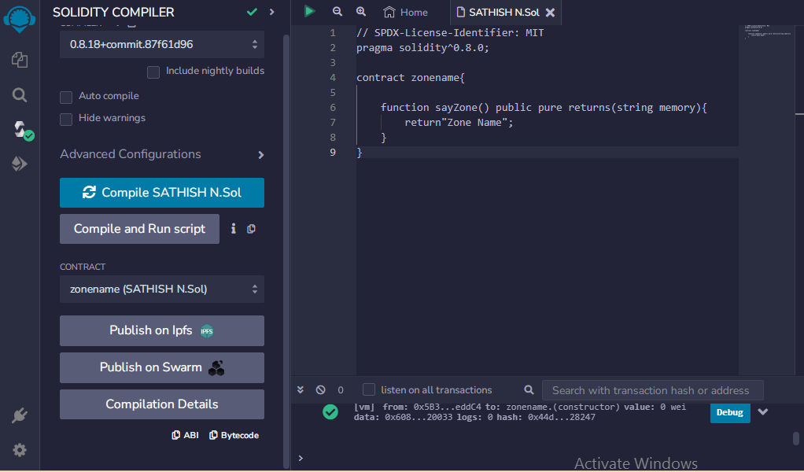

No error has occurred, so we can proceed.

ABI:

[

{

"inputs": [],

"name": "sayZone",

"outputs": [

{

"internalType": "string",

"name": "",

"type": "string"

}

],

"stateMutability": "pure",

"type": "function"

}

]

BYTECODE:



STEP5: Deployment

